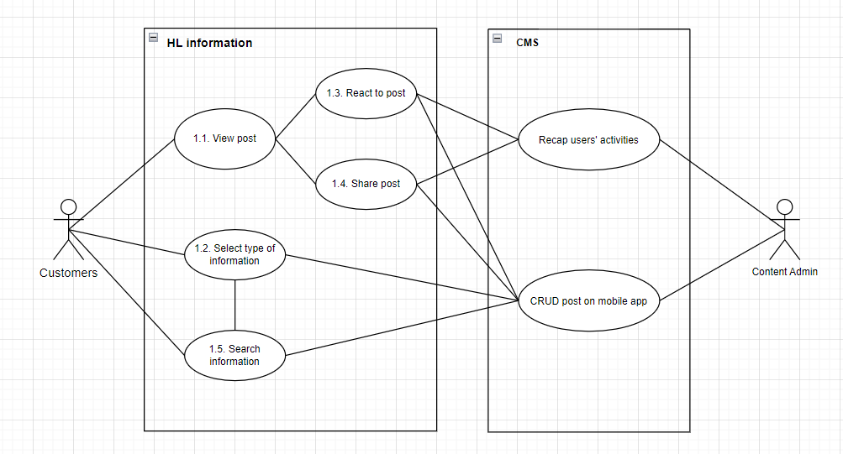

|  |  |
| --- | --- |
| **UC ID** | UC1.5 |
| **UC Name** | Search information |
| **Actor** | Customers, Content Admin |
| **Description** | As a customer, I want to search for information, to quickly view all related information |
| **Priority** | Low |
| **Trigger** | Customer clicks “search” button on navigation bar |
| **Pre-Condition** | 1. Customer has account and already logged in the mobile app 2. Information/Posts are uploaded into the app |
| **Post Condition** | Customer view the post/information they want |
| **Basic Flow** | 1. Customer clicks “search” button on navigation 2. Customer types in the title of the information they want to search for 3. System returns with all related information 4. Customer selects the information they want to view 5. Customer views the information |
| **Alternative Flow** | 2a. Customer select type of information they want to search for  Use Case continue at step 3.  2b. Customer types in keywords of the information they want to search for  Use Case continue at step 3.  2c. Customer types in keywords of the information they want to search for  2c1. Customer select type of information they want to search  Use Case continue at step 3. |
| **Exception Flow** | 2d. Customer clicks “cancel searching”  Use Case stop.  3a. System finds nothing related  Use Case stop. |
| **Business Rule** | 1. The searching information is in English or Vietnamese  2 The searching information is no longer than 32 words |
| **Non-Functional Requirement** | 1. System has to return results less than 15 second  2. System suggests related information due to each word in searching information |

**Activity Diagram**

